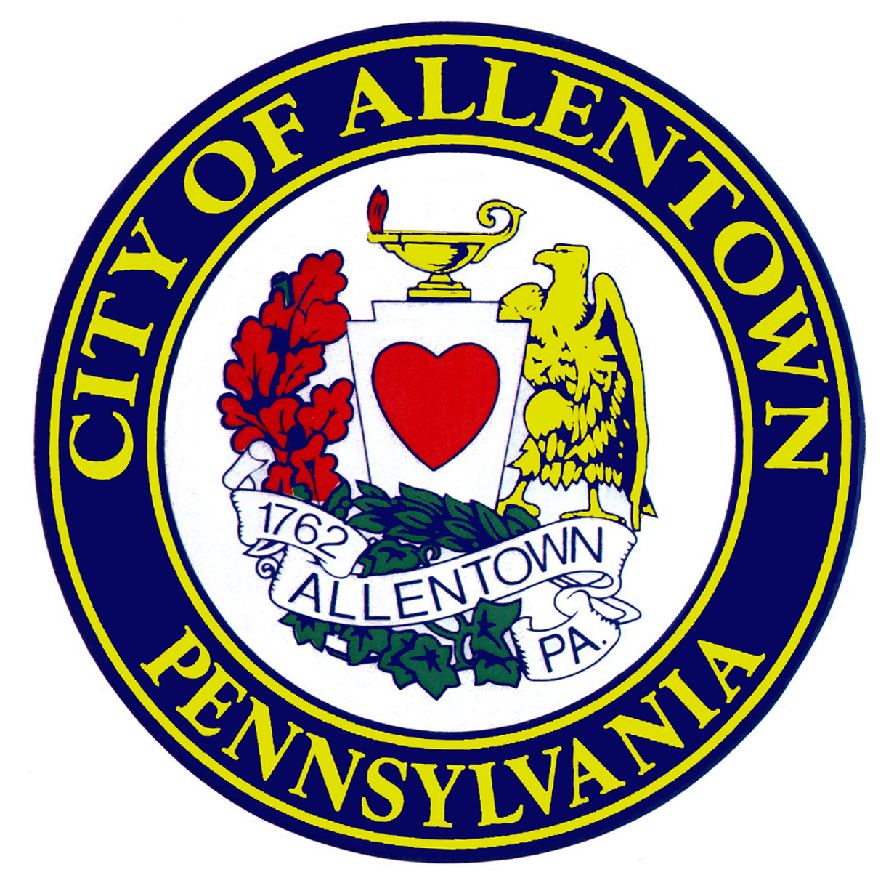
City of Allentown
Hamilton District Façade Loan

The Hamilton District Façade Loan program is administered by the City of Allentown with the goal of improving the appearance of Hamilton Street between 5th and 12th Streets. The purpose of the program is to encourage façade improvements by the use of appropriate design criteria that will highlight the original design elements of the façade. Preference will be given to complete façade re-designs.

Eligible participants: Commercial building owners or commercial tenants on Hamilton Street
between 5th and 12th Streets.

Eligible Costs: Exterior façade improvements; sign repair or replacement; professional
design assistance. This program is intended to encourage facade
Improvements and not to perform routine maintenance.

Loan Amount: Minimum - $5,000 --- Maximum $40,000.
(Loan amount based on 80% of eligible façade renovation project costs up
to $40,000)

Requirements: $300.00 application fee. Business Plan and 50% match identified.
Description of façade work proposed including drawings.

Terms of Loan: 3% interest rate up to 5 year term or equivalent to lease term not to exceed 5 years. Sufficient cash flow to repay loan and evidence of sufficient collateral to secure loan are required. Loan must be secured by 1st or 2nd mortgage lien on real estate (based upon project impact and priority a 3rd lien position may be considered). Other collateral may be considered on a case-by-case basis. Personal guarantees of business owner(s) required.

Approval process: All plans must be approved by Zoning, Building Standards and Safety, Health, and Fire Departments. Compliance with all City requirements including permits and inspections and licenses is required. Any exterior work on the property must meet the Hamilton Street District Façade Guidelines. The City of Allentown reserves the right to approve or reject any application or portion thereof subject to the aesthetic and functional appropriateness of the project as determined by the Director of Community and Economic Development and the Hamilton District Façade Review Board. Other evaluation criterions include impact to target area, number of jobs to be created or retained, and owner’s investment in the project.

Taxes: Applicants receiving funding must be current on all property taxes of the City, County, and School District, City Earned Income Tax, Business Privilege Tax, Business License, Per Capita Tax, Water and Sewer bills, Garbage fees, Municipal liens, and any miscellaneous invoices.

The City of Allentown reserves the right to change or cancel this program at any time.

Information/Application: Erlinda M. Aguiar, Real Estate Development Specialist
City of Allentown, Dept of Community & Economic Development
610-439-5976, aguiar@allentowncity.org

